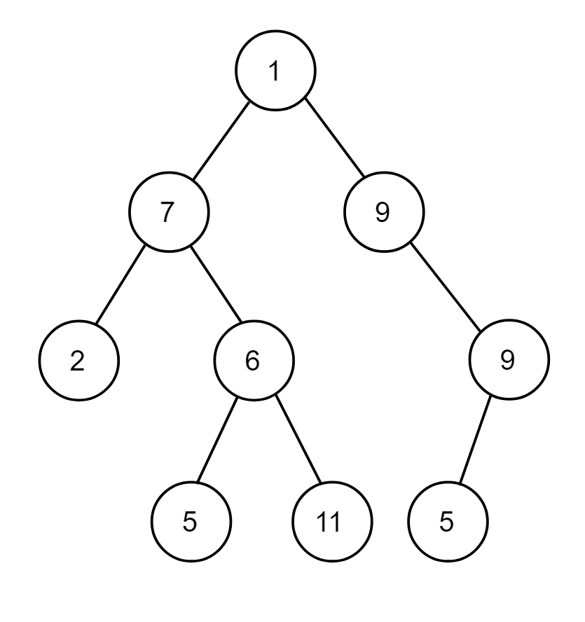

Write preorder, postorder and inorder traversal of this binary tree.

**Answer:**   
Preorder = 1,7,2,6,5,11,9,9,5  
Inorder = 2,7,5,6,11,1,5,9,9   
Postorder = 2,5,11,6,7,5,9,9,1